**DevCom Assignment**

1. What is android? Who created it? What are Android Apps?

**Android** is a [mobile operating system](https://en.wikipedia.org/wiki/Mobile_operating_system) based on a modified version of the [Linux kernel](https://en.wikipedia.org/wiki/Linux_kernel) and other [open source](https://en.wikipedia.org/wiki/Open-source_software) software, designed primarily for [touchscreen](https://en.wikipedia.org/wiki/Touchscreen) mobile devices such as [smartphones](https://en.wikipedia.org/wiki/Smartphone) and [tablets](https://en.wikipedia.org/wiki/Tablet_computer). Android is developed by a consortium of developers known as the [Open Handset Alliance](https://en.wikipedia.org/wiki/Open_Handset_Alliance), with the main contributor and commercial marketer being [Google](https://en.wikipedia.org/wiki/Google).

Applications ("[apps](https://en.wikipedia.org/wiki/Mobile_app)"), which extend the functionality of devices, are written using the [Android software development](https://en.wikipedia.org/wiki/Android_software_development) kit (SDK) and, often, the [Java](https://en.wikipedia.org/wiki/Java_(programming_language)) programming language. Java may be combined with [C](https://en.wikipedia.org/wiki/C_(programming_language))/[C++](https://en.wikipedia.org/wiki/C%2B%2B),together with a choice of non-default [runtimes](https://en.wikipedia.org/wiki/Runtime_library) that allow better C++ support. The [Go](https://en.wikipedia.org/wiki/Go_(programming_language)) programming language is also supported, although with a limited set of [application programming interfaces](https://en.wikipedia.org/wiki/Application_programming_interface) (API).In May 2017, Google announced support for Android app development in the [Kotlin programming language](https://en.wikipedia.org/wiki/Kotlin_(programming_language)).

1. **What is the software used in the development of Android Apps?**

Applications ("[apps](https://en.wikipedia.org/wiki/Mobile_app)") are written using the [Android software development](https://en.wikipedia.org/wiki/Android_software_development) kit (SDK)and, often, the [Java](https://en.wikipedia.org/wiki/Java_(programming_language)) programming language. Java may be combined with [C](https://en.wikipedia.org/wiki/C_(programming_language))/[C++](https://en.wikipedia.org/wiki/C%2B%2B), together with a choice of non-default [runtimes](https://en.wikipedia.org/wiki/Runtime_library) that allow better C++ support. The [Go](https://en.wikipedia.org/wiki/Go_(programming_language)) programming language is also supported, although with a limited set of [application programming interfaces](https://en.wikipedia.org/wiki/Application_programming_interface) (API).In May 2017, Google announced support for Android app development in the [Kotlin programming language](https://en.wikipedia.org/wiki/Kotlin_(programming_language)).

1. **Which are the languages commonly used in the development of android apps? Which**

**language does InstiApp use?**

The [Java](https://en.wikipedia.org/wiki/Java_(programming_language)) programming language. Java may be combined with [C](https://en.wikipedia.org/wiki/C_(programming_language))/[C++](https://en.wikipedia.org/wiki/C%2B%2B), together with a choice of non-default [runtimes](https://en.wikipedia.org/wiki/Runtime_library) that allow better C++ support. The [Go](https://en.wikipedia.org/wiki/Go_(programming_language)) programming language is also supported, although with a limited set of [application programming interfaces](https://en.wikipedia.org/wiki/Application_programming_interface) (API).In May 2017, Google announced support for Android app development in the [Kotlin programming language](https://en.wikipedia.org/wiki/Kotlin_(programming_language)).

The InstiApp uses Kotlin programming language.

1. **What is the activity cycle of a basic Android application? Diagrams/flowcharts**

**Preferred.**

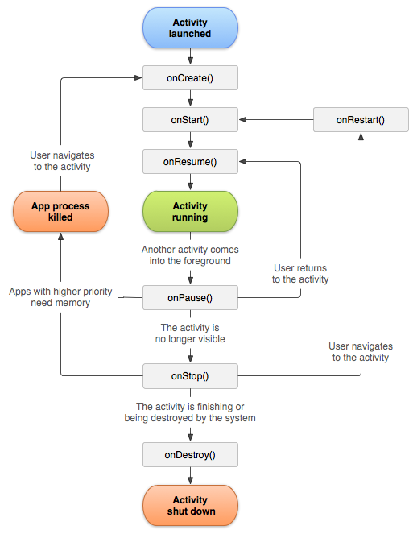

1. **What are 5 different UI elements in an android app?**

TextView, EditText, Buttons, Checkbox, Progressbar, Spinners etc.

1. **[BONUS]What are some of the salient features of those languages(part c)? How similar are they to C++?**
2. Kotlin programming language

Kotlin is a new programming language from [JetBrains](https://www.jetbrains.com/). It first appeared in 2011 when JetBrains unveiled their project named “Kotlin”. Kotlin is an Open-Source Language.

Basically like Java, C and C++ – Kotlin is also “statically typed programming language”. Statically typed programming languages are those languages in which variables need not be defined before they are used. This means that static typing has to do with the explicit declaration or initialization of variables before they are employed.

As Earlier said that Java is an example of a statically typed language, similarly C and C++ are also statically typed languages.

Basically, Static typing does not mean that we have to declare all the variables first before we use them. Variables may be initialized anywhere in the program and we (developers) have to do so, to use those variables anywhere in the program when there is a need. Like in Java, C and C++, the entry point to a Kotlin program is a function named “main”. Basically, it passed an array containing any command line arguments.

|  |  |
| --- | --- |
| **Kotlin** | **C++** |
| Great tooling support | Huge language supports most everything |
| Easy adoption for existing Java programmers | Powerful memory management |
| Easy to learn if you have prior programming experience | Teaches fundamental OOP |
| No runtime overhead | Teaches problem solving |
| Officially supported for Android development | Teaches low-level programming, but doesn't have as many pitfalls as C |
| Low-risk adoption for existing Java codebases | C code can be used in C++ code |
| Does not impose a particular philosophy of programming | Best way to understand algorithms |
| Is built to solve industrial problems | Universal, portable, best complexity/efficiency trade-off |

1. **Go Programming Language (Introduction)**

[**Go**](https://www.geeksforgeeks.org/go-programming-language/) is a procedural programming language. It was developed in *2007* by Robert Griesemer, Rob Pike, and Ken Thompson at Google but launched in *2009* as an open-source programming language. Programs are assembled by using packages, for efficient management of dependencies. This language also supports environment adopting patterns alike to dynamic languages. For eg., type inference (y := 0 is a valid declaration of a variable y of type float).